Preparation of Papers for
THE SIELMEN'2005 CONFERENCE
Ion A. Ionescu, Vasile B. Vasilache, Jr., ... and Pompiliu Popescu
Affiliation of author/authors (only institution, without address)

Abstract – These instructions give you guidelines for preparing an A4 (21cm x 29.7cm) paper in two-column format for the Proceedings of the “5th International Conference On Electromechanical And Power Systems”, Chisinau, October5-6, 2005. sUse this document as a template if you are using Microsoft Word 6.0 or later.
Keywords – a maximum of five keywords
1. LANGUAGE
The paper must be written in good English or French, clear and unambiguous. In order to avoid 'typos', you should check the spelling of your text be means of a computer thesaurus.
2. WE EXPECT YOU
To send us up to July 15, 2005 a paper written in WORD for Windows, both .DOC and .PDF format, via e-mail (mainly to sielmen@ee.tuiasi.ro and a copy to dlucache@net89mail.dntis.ro).
3. PAPER FORMAT
3.1 Paper lenght
The two-column paper length is strictly limited to a maximum of 4 (four) pages including text and figures (please don’t number the pages).

3.2 First page layout
The title in the first page of the paper should be typed after the 4.2 cm interval from the top of the A4 page.
The title of the paper, author's name and affiliation should be page centred.

3.3 Margins
Paper size: A4 (21.x 29.7 cm)
The page margins are of 2cm, only the first page has the top margin of 4.2cm.
Main text of the paper: in two 8.1 cm width columns (the text in columns should be both-side justified).
Space between columns : 0.8cm. Please level the length of columns on last page.
4. FONTS
Text should be justified. Interval between type lines: automatic or single spaced. Use Times New Roman. Please do not intend the text, which should always start at the left side margin. Spaces are 10 pts. before and after: paragraph titles, equations, figures and tables. Spaces before subparagraph titles are of 10 pts..
We encourage to use the predefined styles (the style names begin with S, like “S text”, “S titlu figuri” etc.).
Fonts style and size is sumarised in Table 1. Do not change the font sizes or line spacing to squeeze more text into the limited number of pages. Use italics for emphasis; do not underline.

Table 1 - Font Size and Style
 | size | style
Author's names | 11pts. | Bold
Affiliation | 11pts. | Normal
Title | 16pts. | BOLD UPPER CASE
Abstract text & keywords | 9pts. | Italic
Main text | 10pts. | Normal
Paragraf titles | 10pts. | BOLD UPPER CASE
Subparagraf titles | 10pts. | Bold
Reference titles | 8pts. | Italic
Biography | 8pts. | Normal / Italic
5. EQUATIONS
Number equations consecutively with equation numbers in parentheses flush with the right margin, as in (1). Please use the equation editor to create the equation. To make your equations more compact, you may use the solidus ( / ), the exp function, or appropriate exponents. Use parentheses to avoid ambiguities in denominators.

$\int{ F(r,ϕ)} \text{dr} dϕ=[{σr}_{2} (2μ_{0})] \text{.}$ (1)

Be sure that the symbols in your equation have been defined before the equation appears or immediately following. Italicize symbols (T might refer to temperature, but T is the unit tesla). Refer to “(1),” not “Eq. (1)” or “equation (1),” except at the beginning of a sentence: “Equation (1) is ... .”
6. Tables, Figures and Graphs
Place them straight in the text, preferable at the top and bottom of each column. Place figure captions below the figures (centered); place table titles above the tables (left
Fig.1 - Example of a graph

alignment). Large figures and tables may span both columns and place them at the and of the page, or, preferable at the end of the paper.
Figures and graphs may be in colour but readable when
printed in black and white version. All the lettering should be large enough to be easily legible.
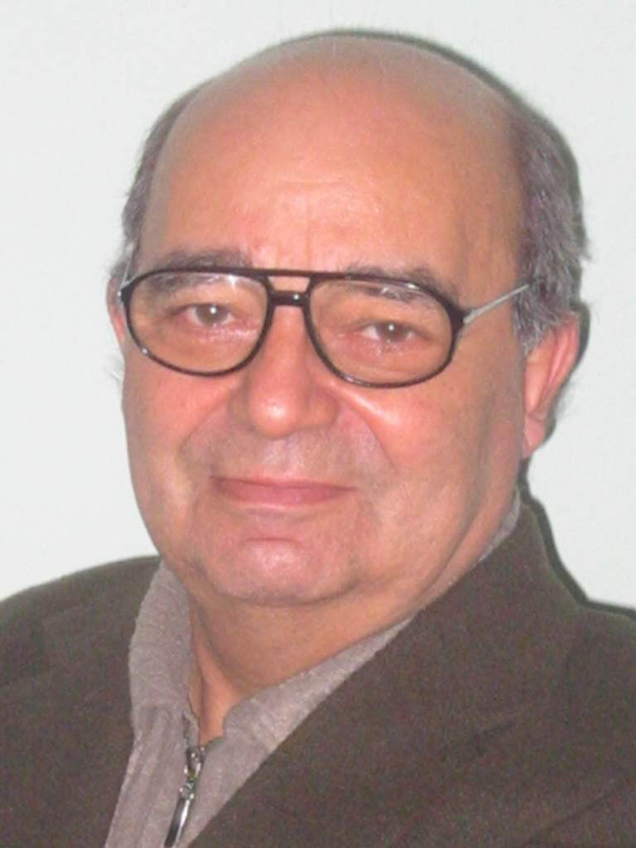
Use the abbreviation “Fig.” even at the beginning of a sentence. Do not abbreviate “Table.”
7. SYMBOLS AND ABBREVIATIONS
Define abbreviations and acronyms the first time they are used in the text, even after they have already been defined in the abstract. Do not use abbreviations in the title unless they are unavoidable.
Symbols and acronyms should be typed clearly and should be defined the first time they appear. Use the International System (SI) of units.
8. Conclusions
Low quality (English/French, content) and lately submitted manuscripts will not be published in the Proceedings and will be cancelled from the final programme of the Conference.
REFERENCES
References should be included in the main text using square brackets[1]. A numerical list of reference should be given at the end of the paper in the order of appearance. Italicize only the paper or book title.

- G. O. Young, Synthetic structure of industrial plastics, Plastics, 2nd ed. vol. 3, J. Peters, Ed. New York: McGraw-Hill, 1964, pp. 15–64
- T. Ambros, P. Todos, L. Cantemir, A. Campeanu, Modern electric conferences, Proceedings of The 4th International Conference on Electromechanical and Power Systems SIELMEN’03, Chisinau, September 26-27, 2003, pp.1-5
- N. Kawasaki, Parametric study of thermal and chemical nonequilibrium nozzle flow, M.S. thesis, Dept. Electron. Eng., Osaka Univ., Osaka, Japan, 1993
- Motorola Semiconductor Data Manual, Motorola Semiconductor Products Inc., Phoenix, AZ, 1989

First A. Author and the other authors are encouraged to include short biographies (optional) at the end of regular papers. The first paragraph may contain a place and/or date of birth (list place, then date). Next, the author’s educational background is listed. The degrees should be listed with type of degree in what field, which institution, city, state or country, and year degree was earned. The author’s major field of study should be lower-cased.
The other paragraph begins with the author’s title and last name (e.g., Dr. Smith, Prof. Jones, Mr. Kajor, Ms. Hunter). If a photograph is provided, the biography will be indented around it. The photograph is placed at the top left of the biography. Personal hobbies will be deleted from the biography.

Second Author and so on….. optional

